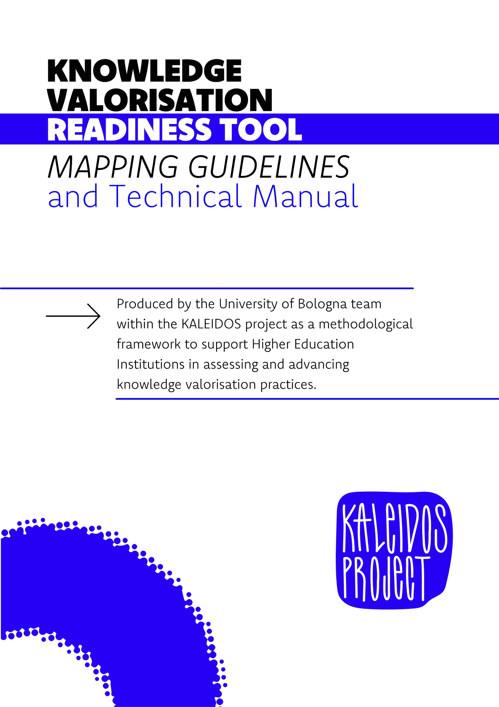

1 PURPOSE AND CONTEXT
2 SELF-ASSESSMENT METHODOLOGY: A TWO-PHASE APPROACH
2.1 Phase 1: Current Configuration Mapping of the KV Ecosystem
2.2 Phase 2: Readiness Assessment t

3 SELF-ASSESSMENT TOOL OUTPUTS
4 FRAMEWORK IMPLEMENTATION

5 LIMITATIONS OF THE SELF-ASSESSMENT TOOL

This self-assessment framework is designed to enable research institutions and universities to systematically diagnose their current configuration and evaluate their readiness for Knowledge Valorisation (KV) strategies and activities. The primary objective is to identify strengths, areas for improvement, and specific "leverage points" for the development of KV strategies.

This model is derived from the methodological approach detailed in Deliverable D4.1 "Policy Guidelines Report" (Grant No. 101132079), which provided a comprehensive assessment of a university's valorisation ecosystem. Its structure has been validated through this application and is proposed as a replicable tool for other institutions aiming to optimize their impact on knowledge valorisation.

The framework is structured into two distinct but interconnected phases:
- Phase 1: Current Configuration Mapping
- Phase 2: Readiness Assessment

While the second phase provides a structured evaluation of readiness, the first phase serves as a preparatory step that significantly enhances the relevance and accuracy of the assessment when completed beforehand.
2.1 PHASE 1: CURRENT CONFIGURATION MAPPING OF THE KV ECOSYSTEM

The first phase is dedicated to collecting descriptive data to delineate a precise overview of the current state of the knowledge valorisation ecosystem within the institution. This mapping covers both the channels through which knowledge is valorised and the enabling factors that influence this process.

The mapping focuses on the following dimensions, in line with the analysis presented in D4.1:
- Knowledge Valorisation Channels
- Knowledge Share Dimensions
2.1.1 KNOWLEDGE VALORISATION CHANNELS
Identification and quantification of activities carried out through key KV channels can follow Box 1, in which each channel is outlined clearly.
BOX – KNOWLEDGE VALORISATION CHANNELS
- Channel 1 | Academia-Industry Joint Research & Mobility
Joint research and inter-sectoral mobility play a strategic role in the valorisation of R&I, fostering a mutual exchange between industry and academia. On the one hand, they facilitate the flow of academic knowledge and results into industries. On the other hand, they offer researchers from academia the opportunity to enhance their skills and gain better knowledge of industrial needs.

- Channel 2 | Promoting research-driven spin-offs and start-ups (access to financing)
The promotion of spin-offs and start-ups is key for the valorisation of R&I results as they offer students and academics an entrepreneurial route to commercialising the knowledge developed. In this context, a crucial role is played by structured access to finance for these early-stage companies as it creates the framework conditions needed to drive the transformation of research results into products and services.

- Channel 3 | Intermediaries and knowledge transfer professionals
Intermediary organisations – such as knowledge transfer offices (KTOs), technology transfer offices (TTOs), business incubators and science parks – create a channel for knowledge valorisation by helping researchers and innovators commercialise their solutions, products and services. They improve the conditions for knowledge transfer by serving as the first contact point for researchers and industry looking for new opportunities. They also promote additional instruments and services to boost the innovation potential of research through networking, mentoring activities, coaching and exchange of best practices.

- Channel 4 | Engagement of citizens, public bodies and societal actors
Citizen engagement is a major way to ensure that new knowledge will not only lead to innovative solutions but will result in those that matter to citizens. Such solutions have a higher societal acceptance and, therefore, are also more effective. When citizens are in the driving seat and in a co-creation process, knowledge has a high potential for societal uptake.

- Channel 5 | Intellectual property management & “standardisation”
The valorisation of research results is facilitated by a fit-for-purpose intellectual property (IP) framework which assures the creators of research outputs a competitive advantage in the business. Standards also have a strong value for knowledge valorisation, facilitating the access of new products to the market.

- Channel 6 | Knowledge circulation & informing policy
Knowledge dissemination and the policy uptake of research results offer another channel for knowledge valorisation. Technology and science are becoming increasingly open, global, interdisciplinary and digital. Ensuring that advances in science and technology are as open as possible is key in our knowledge-driven world where data are increasingly valuable and access to data is considered a competitive advantage. Research results, such as studies, data, models, experiments, and theoretical analyses, are of the greatest benefit to data-informed policymaking. They can help decision-makers better understand the nature of the challenges they are facing and the possible implications of the decisions they may make.

2.1.2 ENABLING FACTORS OF THE KV ECOSYSTEM
The enabling factors guiding the analysis of the contexts and structures supporting knowledge flows across channels are the following:
- Environmental Factors (ENV): Assessment of the institution's integration into the external innovation system (e.g., presence of industrial clusters, access to regional/national/EU funding programs, public innovation policies).
- Organisational Factors (ORG): internal structures, processes, and resources dedicated to KV (e.g., technology transfer offices, IP regulations, allocation of financial and human resources, institutional KV strategies).
- Individual Factors (IND): incentives and capabilities at the level of academic and administrative staff involved in KV (e.g., systems for recognizing KV activities in academic careers, training programs for developing KV competencies, clarity of roles and responsibilities).
Data collection for this phase can utilise documentary analysis (regulations, activity reports), querying internal databases (projects, patents), and structured interviews with key managers and stakeholders.

To ensure effective mapping, it is crucial to rely on a series of introductory questions that guide the collection of pertinent information, ensuring completeness and comparability of the data collected across different dimensions and channels. Such pre-defined questions facilitate the identification of objective data and the organization of existing information.

2.1.3 INTRODUCTORY QUESTIONS FOR MAPPING
The mapping tool is intended to support a structured reflection and analysis of the different channels through a common set of questions provided in the “Questions” column and applied consistently across all channels. This process is designed to facilitate the mapping of the Quadruple Helix actors involved in each channel, as well as the identification of existing practices, structures, dynamics, and levels of development at the environmental, organisational, and individual levels. The exercise should also help highlight strengths, gaps, challenges, and areas requiring further development or institutional support.

To facilitate the initial discussion and support a structured data collection process in Phase 1, the following guiding questions are suggested:
- How is this channel defined within our institution?
- Do we share a common understanding of what this channel includes and excludes?
- Which actors operate within this channel in our context (academia, industry, government, civil society)?
- Are there missing or underrepresented stakeholder groups?
- Which structures or units support this channel (e.g. offices, labs, programmes, working groups)?
- How do regional, national, or EU policies influence this channel within our institution?
- Are there external incentives or funding schemes supporting activities in this channel?
- Is this channel considered institutionalised, under development, or mainly ad hoc?
- What evidence supports the assessment (e.g. strategic plans, metrics, internal reviews)?
- Which dimensions (environmental, organisational, individual) appear to be more or less developed?
2.2 PHASE 2: READINESS ASSESSMENT
The second phase of the framework aims to evaluate the maturity and "readiness" of existing KV activities and processes, as well as the institution's potential for future strategic developments. This phase is based on the perception of key internal and external stakeholders and on qualitative assessment criteria.
2.2.1 READINESS ASSESSMENT FOR KNOWLEDGE VALORISATION CHANNELS
The readiness assessment focuses on the same dimensions as the mapping but with a structured approach and an emphasis on the "as is" and potential of the context. Specifically, each Knowledge Valorisation Channel is assessed through the lens of the three Enabling Factors (Environmental, Organisational, and Individual), providing a granular understanding of how well the institutional environment, structures, and individual capabilities support each specific valorisation activity.

For each channel identified in Phase 1, the level of maturity and the effectiveness of procedures, support, and outcomes are evaluated by assessing its performance across Environmental, Organisational, and Individual Factors. A scalar scoring system, where individual answers range from 1 ("Strongly disagree / Not at all true") to 7 ("Strongly agree / Fully true"), is used to quantify the perception of readiness. These individual scores are then aggregated to generate partial scores at a factor and channel level. These scores quantify the perceived readiness across various dimensions and channels, allowing for a comprehensive overview. Once aggregated, scores can be visually represented (e.g., via radar charts, as illustrated in Figures 1a and 2a of the D4.1 report) to highlight relative strengths and weaknesses across the different areas of valorisation.

This work is a collaborative effort aimed at gathering comprehensive insights through the inclusion of qualitative perspectives from a broad range of stakeholders, including researchers, research support staff, academic and administrative leadership, and external partners, thereby ensuring that different viewpoints and experiences are adequately represented. A dedicated “Notes” column is also included in the readiness tool to capture qualitative observations, comments, and additional reflections emerging during the discussion process.
The application of the self-assessment tool will culminate in the production of a final score, which will describe the maturity and effectiveness of each KV channel and relative enabling factor, with aggregated sub-scores and visual representations (e.g., radar charts) illustrating relative performance.

An integrated analysis of mapping and readiness allows for the easy identification of specific leverage point where strategic interventions can have the greatest impact on improving the valorisation ecosystem.

The outputs may represent a good starting point or an integration to concrete and actionable recommendations, too, for developing more effective and coordinated KV strategies action plans for the alignment with institutional objectives and the external context.

For an effective application of the framework, the following phases are recommended:
- Establishment of the Working Group: Appoint a multidisciplinary team responsible for implementing the self-assessment, including representatives from various functions and hierarchical levels.
- Tool Adaptation: Customize the set of pre-mapping questions and evaluation criteria to align with the specific contextualities and strategic objectives of the institution.
- Data Collection: Systematically execute data collection for the initial mapping phase, to make sure the score obtained after completing the self-assessment tool is as much trustable as possible.
- Analysis and Interpretation: Process the collected data, identifying trends, correlations, and discrepancies, with particular attention to interpreting readiness scores and their correlation with enabling factors.
- Communication and Consolidation: Present the results to key decision-makers and stakeholders to foster consensus and define a shared action plan.
- Monitoring and Improvement Cycle: Establish a continuous monitoring process for actions undertaken and plan periodic re-assessments to track progress and identify new areas for intervention.

This self-assessment framework constitutes a valuable instrument for diagnosing an institution's Knowledge Valorisation ecosystem and identifying strategic opportunities. However, it is important to acknowledge its inherent limitations. Primarily, this tool serves as a mapping instrument designed to provide a structured overview and a snapshot of current configurations and perceived readiness rather than a comprehensive quantitative intervention.

We recognise that the instvitutional context, including its disciplinary focus, significantly influences KV activities and outcomes. For instance, a polytechnic university or an institution with a strong emphasis on STEM fields (Science, Technology, Engineering, and Mathematics) may possess certain prerequisites and a historically embedded culture that inherently guides valorisation activities towards specific channels such as patenting, technology licensing, and collaborative research with industry, often driven by tangible outputs. Conversely, institutions with a predominant focus on Social Sciences and Humanities (SSH), while increasingly engaged in valorisation, might have a different orientation and different objectives.

Therefore, while the framework provides a robust and replicable methodology for assessing KV readiness, users should interpret the results within their specific institutional and disciplinary context. The tool is intended to facilitate internal dialogue and strategic planning, but it does not replace the need for deeper qualitative analysis or tailored strategic interventions that account for these contextual nuances.

The self-assessment tool is provided as a separate Excel file accompanying this manual. Users are invited to use it directly to score their institutional readiness.

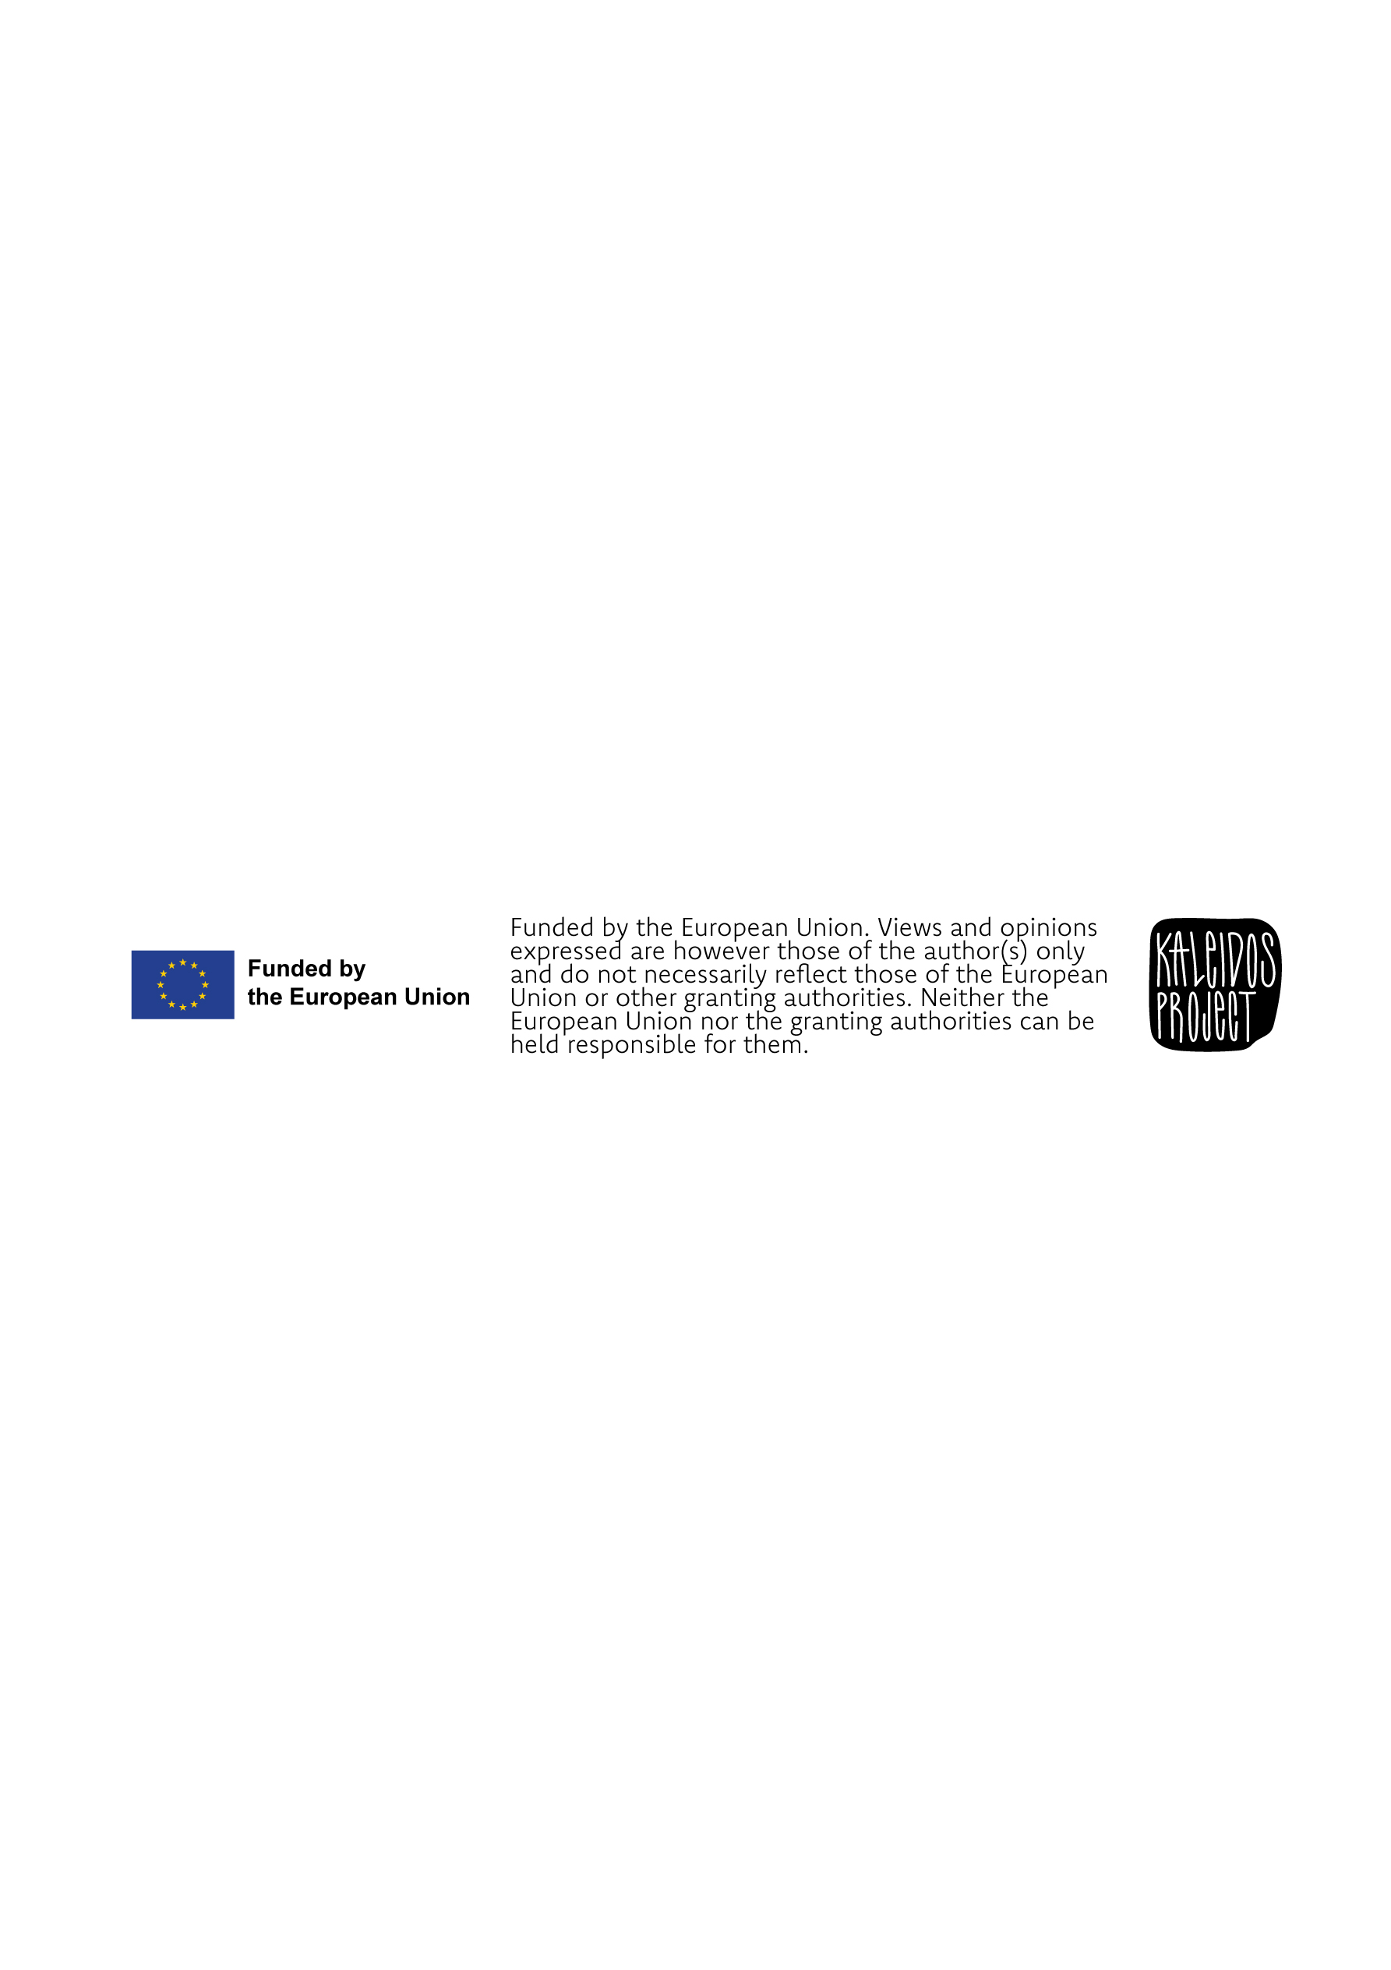

The tool enables self-assessment across the dynamics of knowledge flows within the six Research & Innovation (R&I) Valorisation Channels as outlined in the relative European Commission Policy Brief. See for more: European Commission: Directorate-General for Research and Innovation, Research & innovation valorisation channels and tools – Boosting the transformation of knowledge into new sustainable solutions, Publications Office, 2020, https://data.europa.eu/doi/10.2777/480584
As they appear on Conti, G., & Grimaldi, R. (2024). Knowledge Share: The (R)evolution of Technology Transfer. Springer Cham. https://doi.org/10.1007/978-3-031-51384-8

